Ex. No. 1 | TITLE OF THE EXERCISE
YouTube Link
Date of Exercise | DD.MM.YYYY

Aim
To demonstrate the functionality and control flow of `while` loops in Python for iterative execution based on a specified condition.

Description
A `while` loop in Python is a control flow statement that allows a block of code to be executed repeatedly as long as a given boolean condition remains true. The loop continues to iterate, checking the condition before each execution, until the condition evaluates to false, at which point the loop terminates. Key components typically include an initialization step for a loop control variable, the condition itself which depends on this variable, and an update step for the variable within the loop body to ensure eventual termination. `while` loops are particularly useful in scenarios where the number of iterations is not predetermined, such as processing user input until a specific sentinel value is entered, implementing game loops, or iterating through data structures until a certain state is achieved.

Program
# Program to demonstrate Python while loops
# Example 1: Basic while loop for counting
print("--- Example 1: Basic Counting Loop ---")
count = 1
while count <= 5:
print(f"Current count: {count}")
count += 1
print("Loop 1 finished.\n")
# Example 2: while loop with user input and 'break' statement
print("--- Example 2: User Input Loop with 'break' ---")
print("Enter text. Type 'quit' to exit.")
while True: # Infinite loop until 'break' is encountered
user_input = input("Your input: ")
if user_input.lower() == 'quit':
print("Exiting the input loop.")
break # Exit the loop
print(f"You entered: {user_input}")
print("Loop 2 finished.\n")
# Example 3: while loop with 'continue' statement
print("--- Example 3: Loop with 'continue' ---")
num = 0
while num < 5:
num += 1
if num % 2 == 0: # Skip even numbers
print(f"Skipping even number: {num}")
continue
print(f"Processed odd number: {num}")
print("Loop 3 finished.")

Output Screenshot
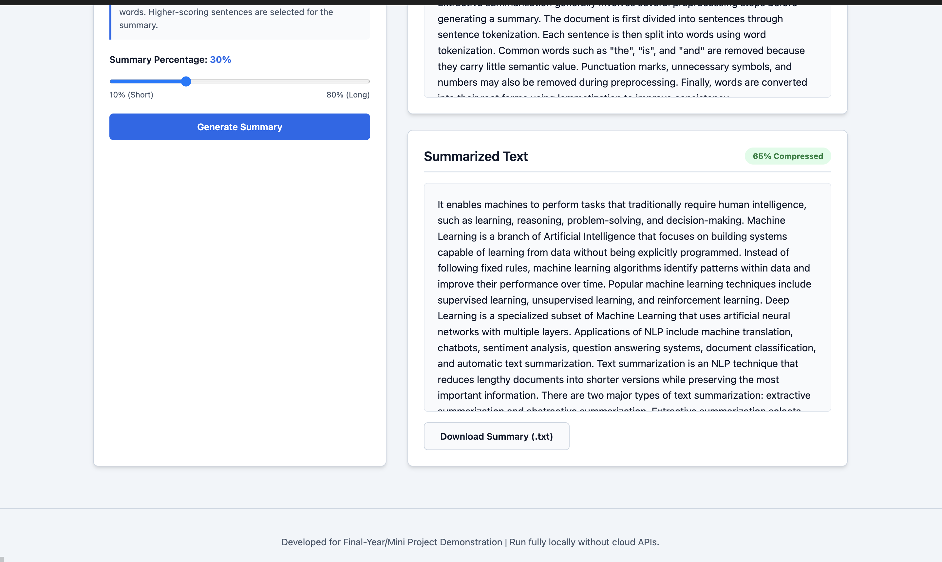

Result
The experiments successfully demonstrated the operation of `while` loops, including basic iterative execution based on a counter, and controlled termination using the `break` statement. The use of `continue` to skip specific iterations was also effectively shown. The objective of understanding and applying `while` loops for conditional repetition in Python was fully achieved.

